**RIPHAH INTERNATIONAL UNIVERSITY, ISLAMABAD**



**Lab 13**

**Bachelors of Computer science – 6th semester**

**Subject:** Artificial Intelligence Lab

**Submitted to:** Ma’am Ayesha

**Submitted by:** Munaza Malik

**Sap Id:** 44956

**Date:** 29th April, 2025

**Lab Tasks**

**Question 01:**

**Decision Tree Algorithm:**

Train a decision tree to predict whether a student will **Pass (1)** or **Fail (0)** based on their study habits. The dataset is given below

| **Hours_Studied** | **Sleep_Hours** | **Tuition_Attended** | **Pass** |
| --- | --- | --- | --- |
| 2 | 5 | 0 | 0 |
| 4 | 6 | 1 | 1 |
| 1 | 4 | 0 | 0 |
| 5 | 7 | 1 | 1 |
| 3 | 6 | 0 | 0 |
| 6 | 8 | 1 | 1 |
| 4 | 5 | 1 | 1 |
| 2 | 6 | 0 | 0 |

* Use this dataset in your code as features X and labels Y.
* Train a Decision Tree Classifier.
* Predict the result for a new student who:
* Studied 3 hours
* Slept 7 hours
* Did attend tuition (Tuition_Attended = 1)
* Show the application and decision tree diagram.
* Visualize the decision tree.

**Solution:**

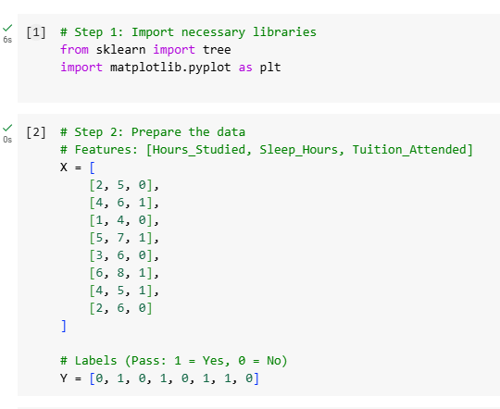 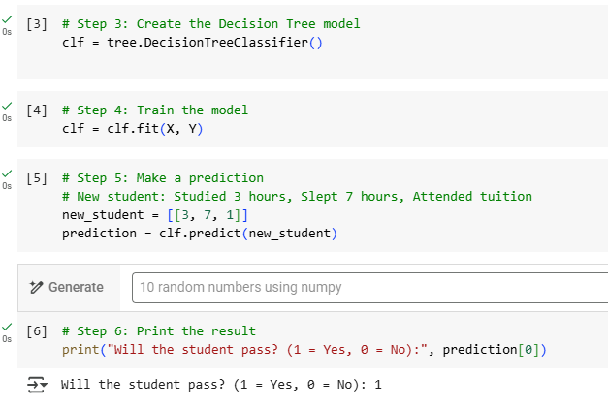 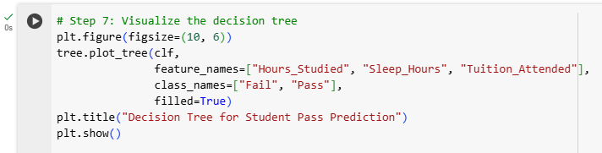

**Output:**

